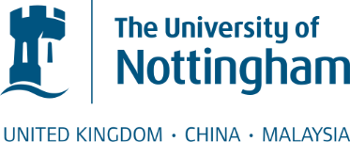

The Third School of English Symposium on Applied Linguistics

The symposium: an introduction
The School of English University of Nottingham Ningbo China is pleased to announce a forthcoming conference --- the Third School of English Symposium on Applied Linguistics on 10th June, 2015.
The Symposium aims to promote academic exchange in the field of applied linguistics among PhD students and researchers. All the full time and part-time PhD students are to present their research in two parallel panels in the morning. The staff members of the school are invited to attend the meeting to give their comments and share their opinions. The annual symposium has been held successfully twice in the school. As before, we would like to invite you to share your work with us this year.
As an important part of the symposium, a research sharing workshop will be held from 2:30-4:30 pm that day. We will invite the School staff members to talk the state of the art in linguistic research. All students and researchers are welcomed to join in the session too.

Call for proposals
Proposals are invited on topics including but not limited to the following aspects of linguistic study:
(Second) language acquisition and teaching
Corpus linguistics
Sociolinguistics
Discourse analysis
Cognitive linguistics
Literary linguistics
Psycholinguistics
Neurolinguistics

For anyone who are interested in our symposium, please send us your proposal to dawei.wei@nottingham.edu.cn. The deadline for the submission of all proposals is 22nd May.
Proposals must be written in English, using 12pt Times New Roman font and being single-spaced. It should be no more than 300 words long including: a title, author(s), affiliation(s), email-address, a text describing research questions, methods, progress and, predictions/conclusions if you have and 3-5 key words. Authors will be notified of acceptance by 25th May.
Each presentation will last 30 minutes, including 15-10 minutes for discussion and questions. Please note that the working language for the symposium is English.
If you have any further inquiries, please feel free to contact Dawei Wei:
Tel: 150 5825 0986
Email: dawei.wei@nottingham.edu.cn

Come and join us
in the University of Nottingham Ningbo China!

